Introduction

Introduction - Ricardo: The Principle of Scarcity
- The interplay of supply and demand in no way rules out the possibility of large and lasting divergence in the distribution of wealth linked to extreme changes in certain relative prices
- Supply and demand principles (market dynamics) do not protect the world economy from the development of wealth gaps

Introduction - Marx: The Principle of Infinite Accumulation
- Principle of infinite accumulation, that is, the inexorable tendency for capital to accumulate and become concentrated in ever fewer hands, with no natural limit to the process.
- Accumulation ends at a finite level, but that level may be high enough to be destabilizing

Introduction - The Kuznets Curve: Good News in the Midst of the Cold War
- The sharp reduction in income inequality that we observe in almost all rich countries between 1914 and 1945 was due above all to the world wars and the violent economic and political shocks they entailed (especially for people with large fortunes).
- Since the 1970s, income inequality has increased significantly in the rich countries, especially the United States
- The concentration of income in the first decade of the 21st century regained and slightly exceed the level attained in the second decade of the previous century

Introduction - The Major Results of This Study
- The reduction in inequality that took place in most developed countries between 1910 and 1950 was above all a consequence of war and of policies adopted to cope with the shocks of war.
- Inequality is not necessarily bad itself: the key question is to decide whether it is justified, whether there are reasons for it.
- Over a long period of time, the main force in favor of greater equality has been the diffusion of knowledge and skills.

Introduction - Forces of Convergence, Forces of Divergence
- In short, the principal force for convergence - the diffusion of knowledge - is only partly natural and spontaneous
- It depends in large part on educational policies, access to training and to the acquisition of appropriate skills and associated institutions
- Top earners can quickly separate themselves from the rest by a wide margin
- This would mean in the simplest form, income inequality is “man-centered” because CEO pay can be set at exponential levels
  - Top managers by and larger have the power to set their own remuneration

Introduction - The Fundamental Force for Divergence: r > g
- r stands for the average annual rate of return on capital (profits, dividends, interest, rents, other income)
- G stands for the rate of growth of the economy
- Wealth divergence - slow growth + high returns to capital
  - In slow growing economies, past wealth naturally takes on disproportionate importance, because it takes only a small flow of new savings to increase the stock of wealth steadily and substantially

Part One: Income and Capital - Income & Output
Income & Output:
- Inequality in wealth created from savings is vastly different than inequality in wealth created from inheritance
- Inequality of wealth - and of the consequent income from capital - is in fact always much greater than inequality of income from labor

The Capital-Labor Split in the Long Run: Not So Stable
- Nature of capital itself has changed radically (from land and other real estate in the 18th century to industrial and financial capital in the 21st century
- The importance of capital in the wealthy countries today is primarily due to a slowing of both demographic growth and productivity growth, coupled with political regimes that objectively favor private capital

The Idea of National Income
- The sum of all income available to the residents of a given country in a given year, regardless of the legal classification of that income.
- National income = domestic output + net income from abroad

What is Capital?
- Capital includes all forms of real property (including residential real estate) as well as financial and professional capital (plants, infrastructure, machinery, patents, and so on) used by firms and government agencies

Capital & Wealth
- Capital in all its forms has always played a dual role, as both a store of value and a factor of production

The First Fundamental Law of Capitalism: a = r x B
- r = the rate of return on capital
- B = capital / income ratio
- Average long-run rate of return:
  - Stocks: 7-8%
  - Real Estate: 3-4%
  - Bonds: 3-4%
  - Public debt: lower

The Global Distribution of Production
- From 1900 to 1980, 70-80% of the global production of goods and services was concentrated in Europe and America, which incontestably dominated the rest of the world
- By 2010, the European-American share had declined to roughly 50%, or approximately the same level as in 1860

The Global Distribution of Income is More Unequal Than the Distribution of Output
- Generally speaking, the global income distribution is more unequal than the output distribution, because the countries with the highest per capita output are also more likely to own part of the capital of other countries and therefore to receive a positive flow of income from capital originating in countries with a lower level of per capita output
- Rich countries are doubly wealthy: they both produce more at home and invest more abroad
- With capitals share of income at about 30%, this means that nearly 20% of African capital is owned by foreigners

What Forces Favor Convergence?
- In essence, all of these countries themselves financed the necessary investments in physical capital and, even more, in human capital, which the latest research holds to be the key to long-term growth
- Knowledge:
  - (1) technological know how
  - (2) skills
  - (3) education
- Many studies show that gains from free trade come mainly from the diffusion of knowledge and from the productivity gains made necessary by open borders, not from static gains associated with specialization, which appear to be fairly modest

Part One: Growth: Illusions and Realities
- Fact: growth in the future will slow and capital will be that much more important
- Past experience shows that the promise of a good outcome is greater when poor countries are able to invest in themselves

Growth ---{demographic component} → population growth
---{economic component} → per capita output growth

The Law of Cumulative Growth
- The Law of Cumulative Growth holds that a low annual growth rate over a very long period of time gives rise to considerable progress
  - Essentially identical to the law of cumulative returns, which says that an annual rate of return of a few percent, compounded over several decades, automatically results in a very large increase of the initial capital, provided that the return is constantly reinvested, or at minimum that only a small portion of it is consumed by the owner of the capital

The Stages of Demographic Growth
- The continual increase in life expectancy is no longer enough to compensate for the falling birth rate, and the pace of population growth slowly reverts to a lower level
- Fertility rate will be the largest determining factor in population growth

Growth as a Factor for Equalization
- Other things being equal, strong demographic growth tends to play an equalizing role because it decreases the importance of inherited wealth: every generation must in some sense construct itself
- Growth can increase social mobility for individuals whose parents did not belong to the elite of the previous generation
  - It wasn’t until the 20th century that economic growth became a tangible, unmistakable reality for everyone

The End of Growth?
- The key point is that there is no historical example of a country at the world technological frontier whose growth in per capita output exceeded 1.5% over a lengthy period of time

An Annual Growth of 1 Percent Implies Major Social Change
- A society in which growth is 0.1 - 0.2% per year reproduces itself with little or no change from one generation to the next
- Growth can create new forms of inequality: for example, fortunes can be amassed very quickly in new sectors of economic activity
- Growth also makes inequalities of wealth inherited from the past less apparent, so that inherited wealth becomes less decisive
- Economic growth is quite simply incapable of satisfying this democratic and meritocratic hope, which must create specific institutions for the purpose and not rely solely on market forces or technological progress

The Loss of Monetary Bearings in the 20th Century
- To pay for this war of extraordinary violence and intensity, to pay for soldiers and for the ever more costly and sophisticated weapons they used, governments went deeply into debt

Part Two: The Dynamics of the Capital/Income Ratio

The Metamorphoses of Capital
- Capital is never quiet: it is always risk-oriented and entrepreneurial, at least at its inception, yet it always tends to transform itself into rents as it accumulates in large enough amounts - that is its vocation, its logical destination
- National capital = farmland + housing + other domestic capital + net foreign capital
- Crucial fact: private wealth in 2010 accounts for virtually all of national wealth for Britain (99%) and France (95%)

The Metamorphoses of Capital in Britain and France

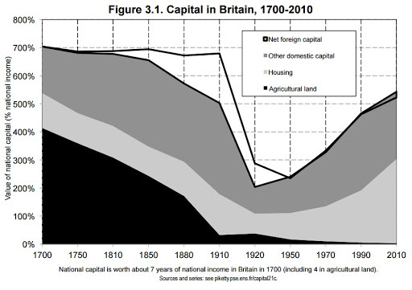

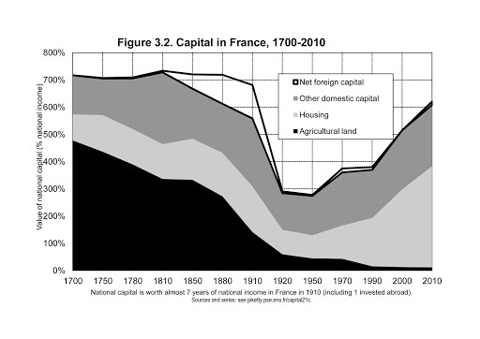
- There can be no doubt that Britain and France in the 1990s and 2000s regained a level of wealth not seen since the early 20th century, at the conclusion of a process that originated in the 1950s.
- In terms of asset structure, 21st century capital has little in common with 18th century capital
- To put it simply, we can see that over the very long run, agricultural land has gradually been replaced by buildings, business capital, and financial capital invested in firms and government organizations
- Yet the overall value of capital, measured in years of national income, has not really changed
- This impressive change is hardly surprising: agriculture in the 18th century accounted for nearly ¾ of all economic activity and employment, compared with just a few percent today.
- The nature of capital has changed: it once was mainly land but has become primarily housing plus industrial and financial assets. Yet it has lost none of its importance

The Rise and Fall of Foreign Capital
- By the turn of the 20th century, capital invested abroad was yielding around 5% a year in dividends, interest, and rent, so that British national income was about 10% higher than its domestic product
- The advantage of owning things is that one can continue to consume and accumulate without having to work.

Great Britain: Public Debt and the Reinforcement of Private Capital
- There is no doubt that Britain’s high level of public debt enhanced the influence of private wealth in British society.
- Interest on British government bonds supplemented land rents as private capital grew to dimensions never before seen
- From the standpoint of people with the means to lend to the government, it is obviously far more advantageous to lend to the state and receive interest on the loan for decades than to pay taxes without compensation
- Inflation was virtually zero from 1815 to 1914 and the interest rate on government bonds was generally around 4-5%, which was significantly higher than the growth rate
  - Under such conditions, investing in public debt was very good business for wealthy people and their heirs
- In the 19th century, lenders were handsomely reimbursed thereby increasing private wealth
- In the 20th century debt was drowned by inflation and repaid with money of decreasing value
- The fact that the bulk of the public debt in practice was owned by a minority of the population resulted in debt becoming the vehicle of important internal redistribution when it was repaid as well as when it is not

France: A Capitalism without Capitalists in the Postwar Period
- The accumulation of significant public assets in the industrial and financial sectors in the period 1950-1980, followed by major waves of privatization of the same assets after 1980
- France had a mixed economy: in a sense a capitalism without capitalists, or at any rate a state capitalism in which private owners no longer controlled the largest firms
- War, Great Depression, and general ruin of the masses caused people to question private capitalism in favor of more nationalism all over Europe

Germany: Rhenish Capitalism and Social Ownership
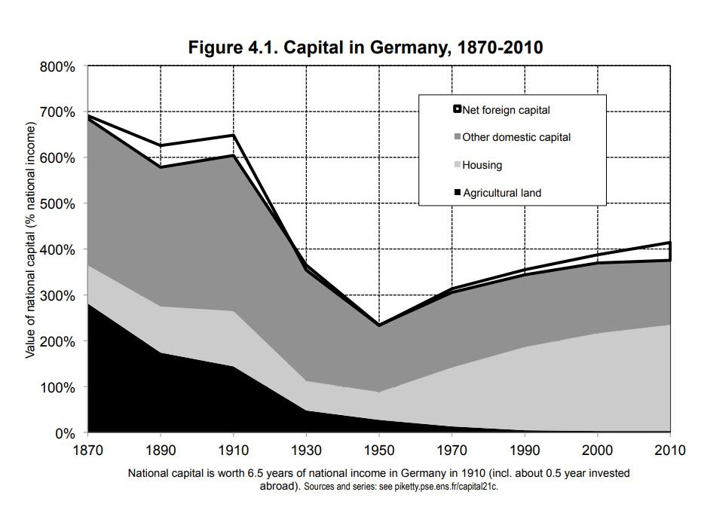
- Germany, the country that made the most dramatic use of inflation to rid itself of debt in the 20th century, refuses to countenance any rise in prices greater than 2% a year, whereas Britain, whose government has always paid its debts, even more than was reasonable, has a more flexible attitude and sees nothing wrong with allowing its central bank to buy a substantial portion of its public debt even if it means slightly higher inflation
- Biggest difference between Germany and France/Britain is the difference in the value of other domestic capital, and primarily the capital of firms. Firms in Germany have a lower stock market valuation than firms in France & Britain
  - These lower valuations reflect the character of Rhenish capitalism or the stakeholder model → model in which firms are owned not only by shareholders but also by certain other interested parties like the firms’ workers themselves

Capital in America: More Stable Than in Europe
- The crucial point is that the number of hectares per person was obviously far greater in North America than in old Europe

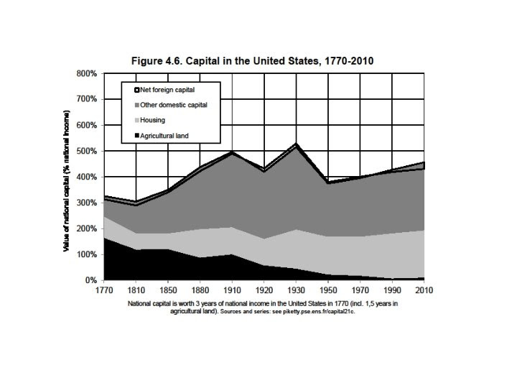

- Make no mistake: the low capital/income ratio in America reflected a fundamental difference in the structure of social inequalities compared with Europe
- The influence of landlords and accumulated wealth was less important in the New World
- Nevertheless the “U-shaped curve” of the capital/income ratio in the 20th century is smaller in amplitude in the United States than in Europe
- In other words, the United States is more than 95% American owned and less than 5% foreign owned

Canada: Long Owned by the Crown
- Canada is thus more than 98% Canadian owned and less than 2% foreign owned

New World and Old World: The Importance of Slavery
- What one finds is that the total market value of slaves represented nearly a year and a half of US national income in the late 18th century and the first half of the 19th century, which is roughly equal to the total value of farmland

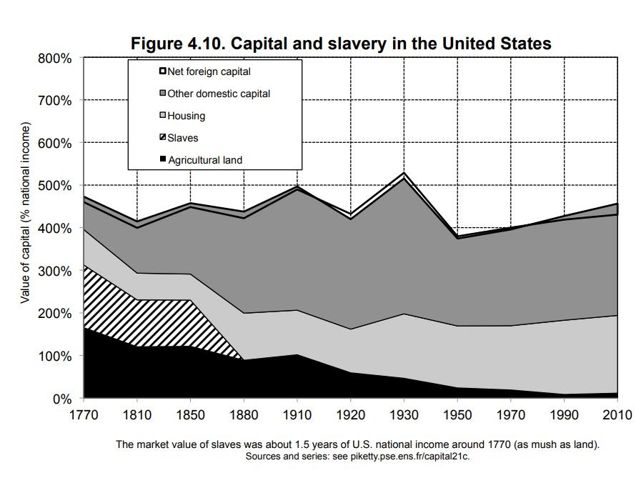

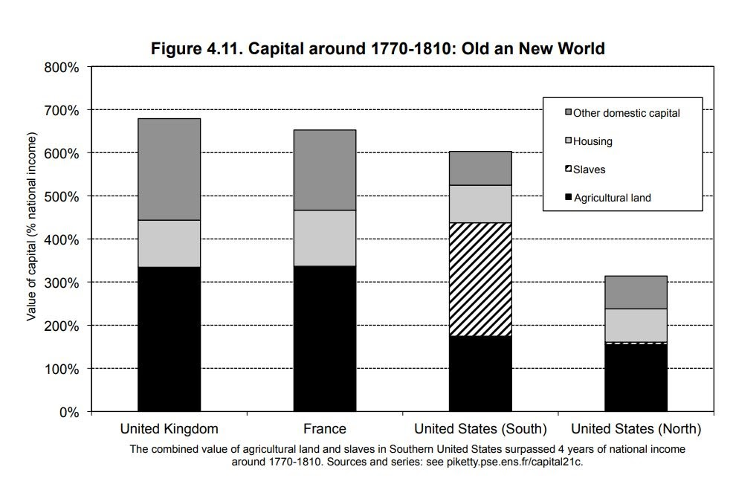
- In the American South, the total value of slaves ranged between two and a half and three years of national income, so that the combined value of farmland and slaves exceed four years of national income
- Their farmland was not worth very much, but since they had the bright idea of owning not just the land but also the labor force needed to work that land, their total capital was even greater
- In the South we find a world where inequalities of ownership took the most extreme and violent form possible, since one half of the population owned the other half
  - Here, slave capital largely supplanted and surpassed landed capital
- This complex and contradictory relation to inequality largely persists in the United States to this day:
  - On the one hand this is a country of egalitarian promise, a land of opportunity for millions of immigrants of modest background
  - On the other hand, it is a land of extremely brutal inequality, especially in relation to race, whose effects are still quite visible

The Capital/Income Ratio over the Long Run
- Over the long run, the nature of wealth was totally transformed: capital in the form of agricultural land was gradually replaced by industrial and financial capital and urban real estate
- Yet the most striking fact was surely that in spite of these transformations, the total value of the capital stock, measured in years of national income - the ratio that measures the overall importance of capital in the economy and society - appears not to have changed very much over a very long period of time
- Private wealth in Europe again surpassed US levels in the early 1990s, and the capital/income ratio there is close to 6 today, compared with slightly more than 4 in United States

The Second Fundamental Law of Capitalism: B = s/g
- B = the capital/income ratio
- s = savings rate
- g = growth rate
- The formula, which can be regarded as the second fundamental law of capitalism, reflects an obvious but important point: a country that saves a lot and grows slowly will over the long run accumulate an enormous stock of capital (relative to its income), which can in turn have a significant effect on the social structure and distribution of wealth
- Decreased growth - especially demographic growth - is thus responsible for capital’s comeback.
- Countries with similar growth rates of income per capita can end up with very different capital / income ratios simply because their demographic growth rates are not the same
- It will take several decades for the law B = s/g to become true
- The general evolution is clear: bubbles aside, what we are witnessing is a strong comeback of private capital in the rich countries since 1970, or, to put it another way, the emergence of a new patrimonial capitalism

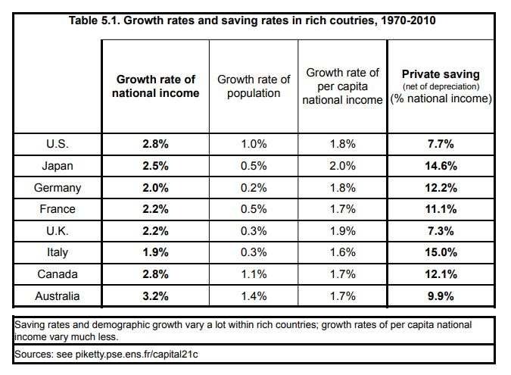
- The new point I want to stress here is that such differences in growth rates have enormous effects on the long-run accumulation of capital and largely explain why the capital / income ratio is structurally higher in Europe and Japan than in the United States
- It is possible to explain the main features of private capital accumulation in the rich countries between 1970 and 2010 in terms of the quantity of savings between those two dates (along with the initial capital endowment) without assuming a significant structural increase in the relative price of assets
- In other words, movements in real estate and stock market prices always dominate in the short and even medium run but tend to balance out over the long run, where volume effects appear generally to be decisive
- Private savings consistent of two components:
  - Savings made directly by private individuals (this is the part of disposable household income that is not consumed immediately)
  - Savings by firms on behalf of the private individuals who own them (retained earnings)
- The privatization or gradual transfer of public wealth into private hands and the “catch-up” of asset prices over the long run.
- In other words, the revival of private wealth is partly due to the privatization of national wealth
- In most countries, public saving was negative (which means that public investment was less than the public deficit: the government invested less than it borrowed or used borrowed money to pay current expenses)
- The last factor explaining the increase in the capital / income ratio over the past few decades is the historic rebound of asset prices.
  - The increase in asset prices between 1950 and 2010 seems broadly speaking to have compensated for the decline between 1910 and 1950
- By 2100, the entire planet could look like Europe at the turn of the 20th century, at least in terms of capital intensity.

The Capital-Labor Split in the 21st Century
- The two countries for which we have the most complete historical data from the 18th century on are once again Britain and France
- In both France and Britain, from the 18th century to the 21st, the pure return on capital has oscillated around a central value of 4-5% a year, or more generally in an interval from 3-6% a year
- The average after-tax return on capital has decreased much more over the long run than the average pretax return
  - It is important to remember that there are many taxes other than income tax to consider: for instance, real estate taxes cut into the return on investments in real estate, and corporate taxes do the same for the income on financial capital invested in firms
- The average tax rate on income from capital is currently around 30% in most of the rich countries
- For individuals whose only capital is a small balance in a checking account, the return in negative, because such balances yield no interest and are eat away by inflation
- Taken together, it is these kinds of investments, in real estate and financial instruments, that account for the bulk of private wealth, and this raises the average rate of return
- Nominal assets are subject to a substantial inflation risk: if you invest 10,000 euros in a checking or savings account or a non-indexed government or corporate bond, that investment is still worth 10,000 euros ten years later, even if consumer prices have doubled in the meantime.
  - In that case, we say that the real value of the investment has fallen by half: you can buy only half as much in goods and services as you could have bought with the initial investment, so that your return after ten years is 50%
- The price of real estate, like the price of shares of stock or parts of a company or investments in a mutual fund, generally rises at least as rapidly as the consumer price index
- Make no mistake: I am obviously not denying that inflation can in some cases have real effects on wealth, the return on wealth, and the distribution of wealth.
  - The effect, however, is largely one of redistributing wealth among asset categories rather than a long-term structural effect
- Inflation primarily plays a role - sometimes desirable, sometimes not - in redistributing wealth among those who have it.
  - In any case, the potential impact of inflation on the average return on capital is fairly limited and much smaller than the apparent nominal effect
- In any case, the rate of return on capital is determined by the following two forces: first technology (what is capital used for?), and second, the abundance of the capital stock (too much capital kills the return on capital.)
- To be sure, it is not a simple task to find the best possible use for each unit of capital around the world, or even within the borders of a single country
- The marginal productivity of capital decreases as the stock of capital increases
- Over a very long period of time, the elasticity of substitution between capital and labor seems to have been greater than one: an increase in the capital income ratio B seems to have led to a slight increase in a, capital’s share of national income, and vice versa
- If capital is to serve as a ready substitute for labor, then it must exist in different forms
- Capital has not disappeared for the simple reason that it is still useful - hardly less useful than in the ear of Balzac and Austen, perhaps - and may well remain so in the future

Principle of Infinite Accumulation
- The principle of infinite accumulation: capitalists accumulate ever increasing quantities of capital, which ultimately leads inexorably to a falling rate of profit (i.e., return on capital), and eventually to their own downfall
  - More generally, if g is close to zero, the long-term capital / income ratio B = s/g tends toward infinity
- Otherwise, capitalist do indeed dig their own grave: either they tear each other apart in a desperate attempt to combat the falling rate of profit (for instance, by waging war over the best colonial investments as Germany and France did in the Moroccan crises of 1905 and 1911), or they force labor to accept a smaller and smaller share of national income, which ultimately leads to a proletarian revolution and general expropriation. In any event, capital is undermined by its internal contradictions
- In the long run, that capital / income ratio adjusts to the savings rate and structural growth rate of the economy rather than the other way around.
Capital’s Comeback in a Low-Growth Regime
- First, the return to a historic regime of low growth, and in particular zero or even negative demographic growth, leads logically to the return of capital
- In stagnant societies, wealth accumulated in the past naturally takes on considerable importance.
- Example: If the savings rate is now around 10% and the growth rate stabilizes at around 1.5% in the very long run, then the global stock of capital will logically rise to six or seven years of income. And if growth falls to 1%, the capital stock could rise as high as 10 years of income.
- There are many uses for capital over the very long run, and this fact can be captured by noting that the long-run elasticity of substitution of capital for labor is probably greater than one.
- With a capital/income ratio of 7 to 8 years and a rate of return on capital of 4-5%, capital’s share of global income could amount to 30% or 40%, a level close to that observed in the 18th and 19th centuries, and it might rise even higher.
The Caprices of Technology
- The principal lesson of this second part of the book is surely that there is no natural force that inevitably reduces the importance of capital and of income flowing from ownership of capital over the course of history.
- To sum up: modern growth, which is based on the growth of productivity and the diffusion of knowledge, has made it possible to avoid the apocalypse predicted by Marx and to balance the process of capital accumulation. But it has not altered the deep structures of capital - or at any rate has not truly reduced the macroeconomic importance of capital relative to labor.

Part Three: The Structure of Inequality
Inequality and Concentration: Preliminary Bearings
- Patrimonial capitalism - is in large part a repetition of the past and characteristic of low-growth environment like the 19th century
- I begin by noting that in all societies, income inequality can be decomposed into three terms:
  - Inequality in income from labor
  - Inequality in the ownership of capital and the income to which it gives rise
  - Interaction between these two terms
- It is illusionary to think that social success can be achieved through study, talent, and effort
- The key question: work or inheritance?
  - The key fact is that in 19th-century France and, for that matter, into the early 20th century, work and study alone were not enough to achieve the same level of comfort afforded by inherited wealth and the income derived from it
- The very high concentration of capital is explained mainly by the importance of inherited wealth and its cumulative effects
  - For example: it is easier to save if you inherit an apartment and do not have to pay rent
- The top centile is a large enough group to exert a significant influence on both the social landscape and the political and economic order
- The 1% who earn the most are not the same as the 1% who own the most
- In most inegalitarian countries, such as the United States in the early 2010s where, as will emerge later, income from labor is about as unequally distributed as has ever been observed anywhere, the top decile gets 35% of the total, whereas the bottom half gets only 25%
- In the most egalitarian countries, the bottom 50% receive nearly twice as much total income as the top 10% which some will say is still too little, since the former group is 5x larger as the latter, whereas in the most inegalitarian countries the bottom 50% receive ⅓ less than the top group.
Inequalities with Respect to Capital: Extreme Inequality
- The distribution of capital ownership, which is extremely inegalitarian everywhere
- The most striking fact is no doubt that in all these societies, half of the population own virtually nothing: the poorest 50% invariably own less than 10% of national wealth, and generally less than 5%
- The top decile in the US most likely owns something closer to 75% of all wealth
- Nearly everyone in the top decile owns his or her own home, but the importance of real estate decreases sharply as one moves higher in the wealth hierarchy.
- In the top centile, by contrast, financial and business assets clearly predominate over real estate.
  - In particular, shares of stock or partnerships constitute nearly the totality of the largest fortunes.
- Housing is the favorite investment of the middle class and moderately well-to-do, but true wealth always consists primarily of financial and business assets.

- I want to insist on this point: the key issue is the justification of inequalities rather than their magnitude as such:
  - The first of these two ways of achieving such high inequality is through a “hyper patrimonial society” (or “society of rentiers”): a society in which inherited wealth is very important and where the concentration of wealth attains extreme levels
  - The second way of achieving such high inequality is relatively new.
    - It was largely created by the United States over the past few decades
    - Here we see that a very high level of total income inequality can be the result of a “hyper meritocratic society”
    - One might call this a society of superstars or super managers
    - The peak of the income hierarchy is dominated by very high incomes from labor rather than by inherited wealth
- At this point, it will suffice to note that the stark contrast I have drawn here between two types of hyper-inegalitarian society:
- A society of rentiers
- A society of super managers
- What primarily characterizes the United States at the moment is a record level of inequality of income from labor
The Reduction of Inequality in France in the 20th century … “Fall of Rentiers in France”
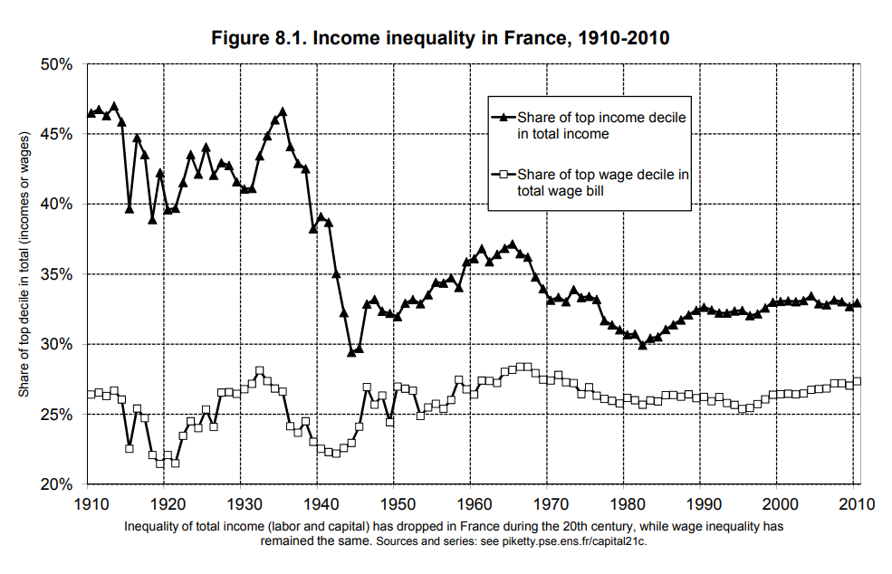
- Income inequality has greatly diminished in France since the Belle Epoque: the upper decile’s share of national income decreased from 45-50 percent on the eve of World War I to 30-35 percent today.
- It mainly reflects the fact that the society of the Belle Epoque was extremely inegalitarian - indeed, one of the most inegalitarian societies of all time
- The significant compression of income inequality over the course of the 20th century was due entirely to diminished top incomes from capital
- If top incomes from the capital had not decreased, income inequality would not have diminished in the 20th century
- To sum up: the reduction of inequality in France during the 20th century is largely explained by the fall of the rentier and the collapse of very high incomes from capital
- In the 20th century it was war, and not harmonious democratic or economic rationality, that erased the past and enabled society to begin anew with a clean slate.

From a “Society of Rentiers” to a “Society of Managers”
- To be sure, today as in the past, income from labor gradually disappears as one moves higher in the income hierarchy, and income from capital becomes more and more predominant in the top centiles and thousandths of the distribution
- Today one has to climb much higher in the social hierarchy before income from capital outweighs income from labor.
- We have gone from a society in which the top centile is dominated by rentiers (people who own enough capital to live on the annual income from their wealth) to a society in which the top of the income hierarchy, including to the upper centile consists mainly of highly paid individuals who live on income from labor.
- Income from capital used to predominate in the top centile but today predominates only in the top thousandth
- Today, one has to be at least a middle manager and increasingly a top manager with a degree from a prestigious university or business school
- The 9% just below the top and the 50% at the bottom are still drawing about the same shares of income from labor over a very considerable period of time
- A person who owns substantial amounts of assets is more likely to reach the top of the income hierarchy
- To sum up: the top decile always encompasses two very different worlds: the 9% in which income from labor clearly predominates, and the 1% in which income from capital becomes progressively more important.
- The share of rent stagnates at around 10% of total income and even tends to diminish in the top centile
  - This pattern reflects the fact that large fortunes consist primarily of financial assets (mainly stocks and shares in partnerships).
- In each war the scenario was the same: in wartime, economic activity decreases, inflation increases, and real wages and purchasing power begin to fall
- It is interesting to note that the capital-labor split tends to move in the same direction as inequality in income from labor, so that the two reinforce each other in the short to medium term but not necessarily in the long run
The Transformation of Inequality in the United States
- US inequality in 2010 is quantitatively as extreme as in old Europe in the first decade of the 20th century, but the structure of that inequality is rather clearly different.
- Structural inequality of income in the US is only slightly explained by capital gains
  - The incessant short-term fluctuations of the stock market add considerable volatility to the evolution of the upper decile’s share
- This is a crucial point: the facts show quite clearly that the financial crisis as such cannot be counted on to put an end to the structural increase in inequality in the United States
- In fact, a very substantial and growing inequality of capital income since 1980 accounts for about ⅓ of the increase in income inequality in the United States
- In 1929, income from capital (essentially dividends and capital gains) was the primary resource for the top 1% of income hierarchy
- In 2007, one has to climb to the 0.1% level before this is true
  - Without capital gains, salaries would be the main source of income up to the 0.01% level of the income hierarchy
- That the vast majority (60 to 70 percent, depending on what definitions one chooses) of top 0.1% of the income hierarchy in 2000-2010 consists of top managers. By comparison, athletes, actors, and artists of all kinds make up less than 5% of this group
  - In this sense, the new US inequality has much more to do with the advent of super managers than with that of superstars
- Nevertheless, 80% of the top income groups are not in finance, and the increase in the proportion of high-earning Americans is explained primarily by the skyrocketing pay packages of top managers of large firms in the nonfinancial as well as financial sectors.

Inequality of Labor Income
- First, a worker’s wage is equal to his marginal productivity, that is, his individual contribution to the output of the firm or office for which he works.
- Second, the worker’s productivity depends above all on his skill and on supply and demand for that skill in a given society
- Determining wage inequality is hard → one must look at the supply and demand of skills
- The state of the training system on the one hand, the state of technology on the other had all play a role in this feature
- Increases in wage inequality in the United States is due to a failure to invest sufficiently in higher education
  - The United States should invest heavily in education so that as many people as possible can attend college
- In the long run, the best way to reduce inequalities with respect to labor as well as to increase the average productivity of the labor force and the overall growth of the economy is surely to invest in education
- Over the long run, education and technology are the decisive determinants of wage levels
- To sum up: the best way to increase wages and reduce wage inequalities in the long run is to invest in education and skills. Over the long run, minimum wages and wage schedules cannot multiply wages by factors of five or ten: to achieve that level of progress, education and technology are the decisive forces
The Rise of the Super manager: An Anglo-Saxon Phenomenon
- The second difficulty - and no doubt the major problem confronting the marginal productivity theory - is that the explosion of very high salaries occurred in some developed countries but not others. This suggests that institutional differences between countries rather than general and a priori universal causes such as technologies change played a central role
- United States, income inequality in 2000-2010 regained the record levels observed in 1910-1920
- The United States was less inegalitarian than Europe in 1900-1910, slightly more inegalitarian in 1950-1960, and much more inegalitarian in 2000-2010
The Illusion of Marginal Productivity
- As noted, the theory of marginal productivity and of the race between technology and education is not very convincing: the explosion of compensation has been highly concentrated in the top centile (or even the top thousandth) of the wage distribution and has affected some countries while sparing others,
- Is it really the case that inequality of individual skills and productivities is greater in the United States today than in the half-illiterate India of the recent past or the apartheid South Africa?
- To my minds, the most convincing explanation for the explosion of the very top US incomes is the following: As noted, the vast majority of top earners are senior manager of large firms
- Remunerations are generally set by hierarchical superiors, and at the very highest levels salaries are set by the executives themselves or by corporate compensation committees whose members usually earn comparable salaries
- Since it is impossible to give a precise estimate of each manager’s contribution to the firm’s output, it is inevitable that this process yields decisions that are largely arbitrary and dependent on hierarchical relationships and on the relative bargaining owner of the individuals involved
- In practice, the invisible hand does not exist, any more than pure and perfect competition does, and the market is always embodied in specific institutions such as corporate hierarchies and compensation committees
- Simply put, wage inequalities increased rapidly in the United States and Britain because US and British corporations became much more tolerant of extremely generous pay packages after 1970
- I noted earlier that the “conservative revolution” that gripped the United States and Great Britain in the 1970s and 1980s, and that led to, among other things, greater tolerance of very high executive pays.
  - In fact, we observe just the opposite: it is when sales and profits increase for external reasons that executive pay rises most rapidly ---> pay for luck
- The decrease in the top marginal income tax rate led to an explosion of very high incomes, which then increased the political influence of the beneficiaries of the change in the tax laws, who had an interest in keeping top tax rates low or even decreasing them further and who could use their windfall to finance political parties, pressure groups, and think tanks.
Inequality of Capital Ownership
- As noted in Chapter 7, the distribution of wealth -- and therefore of income from capital -- is always much more concentrated than the distribution of income from labor
- Both before and after the Revolution, France was a patrimonial society characterized by a hyper concentration of capital, in which inheritance and marriage played a key role and inheriting or marrying a large fortune could procure a level of comfort not obtainable through work or study
- Wealth in Britain was extremely concentrated in the 19th century and showed no tendency to decrease before 1914
- Sweden was not the structurally egalitarian country that was sometimes imagined
- In the Belle Epoque, wealth was highly concentrated in all European countries. It is essential to understand why this was so, and why things changed so much over the course of the 20th century
- In every case, we find that what the wealthiest 10% lost mainly benefited the “patrimonial middle class” (defined as the middle 40% of the wealth hierarchy) and did not go to the poorest half of the population, whose share of total wealth has always been minuscule (generally around 5%)
- Not enough time had passed for wealth to be accumulated or concentrated
- It is well established fact that wealth in the United States became increasingly concentrated over the course of the 19th century
- The differences between the European and US experiences are clear. In Europe, the 20th century witnessed a total transformation of society: inequalities of wealth, which on the eve of World War I was as great as it had been under the Ancient Regime, fell to an unprecedentedly low level, so low that nearly half the population were able to acquire some measure of wealth and for the first time to own a significant share of national capital.
- In the United States, the 20th century is not synonymous with a great leap forward in social justice. Indeed, inequality of wealth is greater today than it was at the beginning of the 19th century
- Concretely, this means that wealth accumulated in the past is recapitalized much more quickly than the economy grows, even when there is no income from labor
- Thus, throughout most of human history, the inescapable fact is that the rate of return on capital was always at least 10 to 20 times greater than the rate of growth of output and income
- Global growth is likely to be around 1.5% a year between 2050 and 2100, roughly the same rate as in the 19th century. The gap between r and g would then return to a level comparable to that which existed during the Industrial Revolution.
- All other things equal, a more patient society, or one that anticipates future shocks, will of course amass greater reserves and accumulate more capital
- Clearly, equality of rights and opportunities is not enough to ensure an egalitarian distribution of wealth
- In other words, the fundamental inequality r > g can explain the very high level of capital inequality observed in the 19th century, and thus in a sense the failure of the French Revolution
Merit and Inheritance in the Long Run
- The inequality r > g in one sense implies that the past tends to devour the future: wealth originating in the past automatically grows more rapidly, even without labor, than wealth stemming from work, which can be saved
- Other things being equal, for a given B and u, a society with a lower mortality rate is also a society in which the flow of inheritance is a smaller proportion of national income
- Clearly, saving for retirement is only one of many reasons -- and not the most important reason -- why people accumulate wealth: the desire to perpetuate the family fortune has always played a central role
- The corrected wealth of the dead is nearly twice as great as that of the living. We are once again living in a golden age of gift giving, much more so than in the 19th century
- The very rapid increase of wealth among the elderly in the late 19th and early 20th centuries was a straightforward consequence of the inequality r > g and of the cumulative and multiplicative logic it implies
- The fact remains that beyond a certain threshold, capital tends to reproduce itself and accumulates exponentially
- In this respect, it was indeed the two world wars that wiped the slate clean in the 20th century and created the illusion that capitalism had been overcome
- The world to come may well combine the worst of two past worlds: both very large inequality of inherited wealth and very high wage inequalities justified in terms of merit and productivity (claims with very little factual basis, as noted.
- It is obvious that education plays a more important role today than in the 18th century
- Indeed, inequalities of training have to a large extent simply been translated upward, and there is no evidence that education has really increased intergenerational mobility
- In other words, we have moved from a society with a small number of very wealthy rentiers to one with a much larger number of less wealthy rentiers: a society of petits rentiers if you will
- In other words, nearly one-sixth of each cohort will receive an inheritance larger than the amount the bottom half of the population earns through labor in a lifetime
The Rentier, Enemy of Democracy
- Second, there is no guarantee that the distribution of inherited capital will not ultimately become as inegalitarian in the 21st century as it was in the 19th
- Our democratic societies rest on a meritocratic worldview, or at any rate a meritocratic hope, by which I mean a belief in a society in which inequality is based more on merit and effort than on kinship and rents
- In a democracy, the professed equality of rights of all citizens contrasts sharply with the very real inequality of rights of all citizens contrasts sharply with the very real inequality of living conditions, and in order to overcome this contradiction it is vital to make sure that social inequalities derive from rational and universal principles rather than arbitrary contingencies
- Today, the rents produced by an asset are nothing other than the income on capital, whether in the form of rent, interest, dividends, profits, royalties, or any other legal category of revenue, provided that such income is simply remuneration from ownership of the asset, independent of any labor.
- When growth is slow, it is almost inevitable that this return on capital is significantly higher than the growth rate, which automatically bestows outsized importance on inequalities of wealth accumulated in the past
- The growing sophistication of capital markets and financial intermediation tends to separate owners from managers more and more and thus sharpen the distinction between pure capital income and labor income.
- To recapitulate: the fundamental force for divergence, which I have emphasized throughout the book, can be summed up in the inequality r >g.
- If population growth in the United States someday decreases, as long-term forecasts suggest it will, then inherited wealth will probably rebound as strongly there as in Europe
Global Inequality of Wealth in the 21st Century
- Thus, unequal returns on capita are a force of divergence that significantly amplified and aggravates the effects of the inequality r > g.
- Global inequality of wealth in the early 2010s appears to be comparable in magnitude to that observed in Europe in 1900-1910
- Once a fortune is established, the capital grows according to a dynamic of its own, and it can continue to grow at a rapid pace for decades simply because of its size
- Obviously, wealth is not just a matter of merit. The reason for this is the simple fact that the return on inherited fortunes is often very high solely because of their initial size.
- r > g, combined with the inequality of returns on capital as a function of initial wealth, can lead to excessive and lasting concentration of capital: no matter how justified inequalities of wealth may be initially, fortunes grow and perpetuate themselves beyond all reasonable limits and beyond any possible rational justification in terms of social utility
- This is the main justification for a progressive annual tax on the largest fortunes worldwide. Such a tax is the only way of democratically controlling this potentially explosive process while preserving entrepreneurial dynamism and international economic openness
- The advantage of a progressive tax on capital is that is provides a way to treat different situations in a supple, consistent, and predictable manner while exposing large fortunes to democratic control - which is already quite a lot
- A tax on capital would be a less blunt and more systematic instrument for dealing with the question of ill-gotten gains or unjustified wealth
- Broadly speaking, the central fact is that the return on capital often inextricably combines elements of true entrepreneurial labor (an absolutely indispensable force for economic development), pure luck (one happens at the right moment to buy a promising asset at a good price), and outright theft
  - The arbitrariness of wealth accumulation is a much broader phenomenon than the arbitrariness of inheritance
The Pure Return on University Endowments
- There are currently more than eight hundred public and private universities in the United States that manage their own endowments
  - The top-ranked universities are invariably...
    - Harvard (with an endowment of some $30 billion in the early 2010s)
    - Yale ($20 billion)
    - Princeton and Stanford (more than $15 billion)
    - MIT and Columbia (less than $10 billion)
    - Chicago and Pennsylvania ($7 billion)
  - All told, these eight hundred US universities owned nearly $400 billion worth of assets in 2010
- But the important point is that if we average over ten, twenty, or thirty years, we find extremely high returns, of the same sort I examined for the billionaires in the Forbes rankings
  - The higher we go in the endowment hierarchy, the more often we find “alternative investment strategies,” that is, very high yield investments such as shares in private equity funds and unlisted foreign stocks (which require great expertise), hedge funds, derivatives, real estate, and raw materials, including energy, natural resources, and related products (these, too, require specialized expertise and offer very high potential yields).
  - Said differently, when you have a lot of capital you can be riskier. Thus, your total capital can grow more than the average.
- In other words, the higher returns of the largest endowments are not due primarily to greater risk taking but to a more sophisticated investment strategy that consistently produces better results
- Concretely, Harvard currently spends nearly $100 million a year to manage its endowment.
  - This munificent sum goes to pay a team of top-notch portfolio managers capable of identifying the best investment opportunities around the world.
  - Given the size of Harvard’s endowment ($30 billion), $100 million in management costs is just over 0.3% per year.
- These results are striking, because they illustrate in a particularly clear and concrete way how large initial endowments can give rise to better returns and thus to substantial inequalities in returns on capital
- As noted, a gap r - g of fairly modest size is all that it takes to arrive at an extremely inegalitarian distribution of wealth
What Is the Effect of Inflation on Inequality of Returns to Capital?
- The rate of inflation in the wealthy countries has been stable at around 2% since the 1980s
- By contrast, it is likely that inflation changes the distribution of this average return among individual citizens
- This is partly true, in the sense that inflation forces people to pay some attention to their capital
- Inflation is a tax on the idle rich, on the wealth that is not invested
- There is unequal access to real estate as an effect of fortune size has of course always existed
- To sum up: the main effect on inflation is not to reduce the average return on capital but to redistribute it.
- To be sure, inflation may slightly reduce the pure return on capital, in that it forces everyone to spend more time doing asset management.
- A progressive tax on capital is a much more appropriate policy in terms of both democratic transparency and real efficacy
The Return on Sovereign Wealth Funds: Capital and Politics. Will China Own the World?
- Investing in hedge funds, unlisted shares, and commodities-based derivatives
- Billionaires today own roughly 1.5% of the world’s total private wealth, and sovereign wealth funds own another 1.5%.
- The diffusion of knowledge and productive technologies is a fundamentally equalizing process: once the less advanced countries catch up with the more advanced, they cease to grow more rapidly.
- In particular, it is important to stress that the currently prevalent fear of growing Chinese ownership is a pure fantasy.
  - The wealthy countries are in fact much wealthier than they sometimes think
  - The total real estate and financial assets net of debt owned by European households today amount to some 70 trillion euros
  - By comparison, the total assets of the various Chinese sovereign wealth funds plus the reserves of the Bank of China represent around 3 trillion euros, or less than 1/20th the former amount
- In other words, 97% of today’s very high real estate prices are due to the fact that there are enough French buyers residing in France who are prosperous enough to pay such large amounts for property.
- The main reason for the feeling of dispossession that grips the rich countries today is the loss of democratic sovereignty

Part Four: Regulating Capital in the 21st Century
A Social State for the 21st Century
- Progressive global tax on capital would expose wealth to democratic scrutiny, which is a necessary condition for effective regulation of the banking system and international capital flows
- A progressive tax on capital is a more suitable instrument for responding to the challenges of the 21st century than a progressive income tax, which was designed for the 20th century (although the two tools can play complementary roles in the future).
- The growth of the fiscal state over the last century basically reflects the constitution of a social state
  - Increase in taxes from 10% to 30-45% of national income to pay for:
    - Healthcare for every person
    - Education for every person
    - Pension for every person
- Modern redistribution is built around a logic of rights and a principle of equal access to a certain number of goods deemed to be fundamental
  - Modern redistribution, as exemplified by the social states constructed by the wealth countries in the 20th century, is based on a set of fundamental social rights: to education, health, and retirement
Do Educational Institutions Foster Social Mobility?
- In all countries, on all continents, one of the main objectives of public spending for education is to promote social mobility
- Qualification levels shifted upward: a high school diploma now represents what a grade school certificate used to mean, a college degree what a high school diploma used to stand for, and so on.
- The available data suggests that social mobility has been and remains lower in the United States than in Europe
- Parents’ income has become an almost perfect predictor of university access
- By comparing various sources of data, moreover, it is possible to estimate the average income of the parents of Harvard students is currently about $450,000, which corresponds to the average income of the top 2% of the US income hierarchy
- The difference between continental Europe and the United States: in Europe most people believe that access to higher education should be free or nearly free, just as primary and secondary education are
- Make no mistake: there is no easy way to achieve real equality of opportunity in higher education
Rethinking the Progressive Income Tax
- How can sovereign citizens democratically decide how much of their resources they wish to devote to common goals such as education, health, retirement, inequality reduction, employment, sustainable development, and so no?
- There has been a complete reversal of the right-wing position on progressive taxation since the disasters of the world wars
- A more realistic explanation is that lower top income tax rates, especially in the United States and Britain, where top rates fell dramatically, totally transformed the way executive salaries are determined
  - Because it is objectively difficult to measure individual contributions to a firm’s output, top managers found it relatively easy to persuade boards and stockholders that they were worth the money, especially since the members of compensation committees were often chose in a rather incestuous manner
- A new argument has recently been advanced: it is possible that the US economy has become more innovative in recent years but that this innovation does not show up in the productivity figures because it spilled over into the other wealthy countries, which have thrived on US inventions. It would nevertheless be quite astonishing if the United States, which has not always been hailed for international altruism, were proven not to have retained some of this enhanced productivity for itself.
A Global Tax on Capital
- The issue of financial transparency and information sharing is closely related to the ideal tax on capital.
- Here, the important point to keep in mind is that the capital tax I am proposing is a progressive annual tax on global wealth
- The primary purpose of the capital tax is not to finance the social state but to regulate capitalism.
  - The goal is first to stop the indefinite increase of inequality of wealth, and second to impose effective regulation on the financial and banking system in order to avoid crises
- Without a global tax on capital or some similar policy, there is a substantial risk that the top centile’s share of global wealth will continue to grow indefinitely --- and this should worry everyone.
  - In any case, truly democratic debate cannot proceed without reliable statistics
- It is not right for individuals to grow wealthy from free trade and economic integration only to rake off the profits at the expense of their neighbors ---> this is outright theft
What is the Purpose of a Tax on Capital?
- The contributive logic is quite simple: income is often not a well-defined concept for very wealthy individuals, and only a direct tax on capital can correctly gauge the contributive capacity of the wealthy
- Effective tax rates (expressed as a percentage of economic income) are extremely low at the top of the wealth hierarchy, which is problematic, since it accentuates the explosive dynamic of wealth inequality, especially when larger fortunes are able to garner larger returns
- Capital is a better indicator of the contributive capacity of very wealthy individuals than is income, which is often difficult to measure.
  - A tax on capital is thus needed in addition to the income tax for those individuals whose taxable income is clearly too low in light of their wealth
- The purpose of the tax on capital is thus to force people who use their wealth inefficiently to sell assets in order to pay their taxes, thus ensuring that those assets wind up in the hands of more dynamic investors
- The unpredictability of the return on capital explains, moreover, why it is more efficient to tax heirs not once and for all, at the moment of inheritance (by way of the estate tax), but throughout their lives, via taxes based on both capital income and the value of the capital stock
  - In other words, all three types of tax --- on inheritance, income, and capital --- play useful and complementary roles (even if income is perfectly observable for all taxpayers, no matter how wealthy)
A Blueprint for a European Wealth Tax
- That is why the rates of an annual tax on capital must be much lower, on the order of a few percent
- The crux of the problem is this: without automatic sharing of bank information among European countries, which would allow the tax authorities to obtain reliable information about the net assets of all taxpayers, no matter where those assets are located, it is very difficult for a country acting on its own to impose a progressive tax on capital
- A tax on capital would be a less violent and more efficient response to the eternal problem of private capital and its return
Redistribution Through Immigration
- Immigration is the mortar that holds the United States together, the stabilizing force that prevents accumulated capital from acquiring the importance it has in Europe.
The Question of the Public Debt
- The problem with debt is that is usually has to be repaid, so that debt financing is in the interest of those who have the means to lend to the government
- The developed world is currently indebted at a level not seen since 1945
- The rich world is rich, but the governments of the rich world are poor
- The fact is that all economists --- monetarists, Keynesians, and neoclassicals --- together with all other observers, regardless of their political stripe, have agreed that central banks ought to act as lenders of last resort and do whatever is necessary to avoid financial collapse and a deflationary spiral
- What is certain is that when central banks increase the money supply by lending to a financial or nonfinancial corporation or a government, there is no immediate impact on national capital (both public and private)
- Rapid execution is the principal strength of the monetary authorities
Reducing Public Debt: Tax on Capital, Inflation, and Austerity
- Three main methods to reduce public debt: taxes on capital, inflation, and austerity
- But the main advantage of a fiscal solution is that the contribution demanded of each individual can be adjusted to the size of his fortune
- The primary and indispensable role of central banking is to ensure the stability of the financial system
Does Inflation Redistribute Wealth?
- It takes decades to accumulate capital; it can also take a very long time to reduce a debt
Government and Capital Accumulation in the 21st Century
- Edmund Phelps baptized the equality r = g the “golden rule of capital accumulation”
- It is unlikely that any human society will accumulate that much capital
- In other words, in order for the golden rule to be satisfied, one has to have accumulated so much capital that capital no longer yields anything
- That is what a = s means: all of the return of capital must be saved and added back to the capital stock
- Conversely, if r > g, then capital returns something in the long run, in the sense that it is no longer necessary to reinvest all of the return on capital to maintain the same capital / income ratio
- The inequality r > g is the basis of a society of rentiers
  - Accumulating enough capital to reduce the return to the growth rate can therefore end the reign of the rentier
- Make no mistake: I have no particular liking for public debt. As I noted earlier, debt often becomes a backhanded form of redistribution of wealth from the poor to the rich, from people with modest savings to those with the means to lend to the government (who as a general rule ought to be paying taxes rather than lending)
- Private wealth rests on public poverty, and one particularly unfortunate consequence of this is that we currently spend far more in interest on the debt than we invest in higher education
- If democracy is someday to regain control of capitalism, it must start by recognizing that the concrete institutions in which democracy and capitalism are embodied need to be reinvented again and again

Conclusion
- The Central Contradiction of Capitalism: r > g
- The overall conclusion of this study is that a market economy based on private property, if left to itself, contains powerful forces of convergence, associated in particular with the diffusion of knowledge and skills
- But it also contains powerful forces of divergence, which are potentially threatening to democratic societies and to the values of social justice on which they are based
- The entrepreneur inevitably tends to become a rentier, more and more dominant over those who own nothing but their labor
- Historical experience shows, moreover, that such immense inequalities of wealth have little to do with the entrepreneurial spirit and are of no use in promoting growth

Source
http://piketty.pse.ens.fr/files/capital21c/en/pdf/F4.10.pdf

To sum up what has been said thus far: the process by which wealth is accumulated and distributed contains powerful forces pushing toward divergence, or at any rate toward an extremely high level of inequality. Forces of convergence also exist, and in certain countries at certain times, these may prevail, but the forces of divergence can at any point regain the upper hand, as seems to be happening now, at the beginning of the 21st century. The likely decrease in the rate of growth of both the population and the economy in coming decades makes this trend all the more worrisome.

